Business Requirements Document(BRD)

UI Development

May 2016

Version 1.1



# Version Control

|  |  |  |  |
| --- | --- | --- | --- |
| Date | Version Number | Document Changes | Revision Owner |
|  |  |  |  |
| 1 | 1.1 | Initial Draft | Yohan John |
|  |  |  |  |
|  |  |  |  |
|  |  |  |  |
|  |  |  |  |
|  |  |  |  |

# Approval Chart

|  |  |  |  |  |
| --- | --- | --- | --- | --- |
| **Role** | **Name** | **Title** | **Signature** | **Date** |
| Project Sponsor | Mani Jacob | BEAM Real Estate LLC |  |  |
| Business Owner | Tim Jacob | Kings University - Gateway |  |  |
| Project Manager | Yohan John | Cedent Inc – Frisco,Tx |  |  |
| System Architect | Aaraj | Software Solutions, Bangalore |  |  |
| Development Lead | Aaraj | Software Solutions, Bangalore |  |  |
| User Experience Lead | Sujith Thomas Koshy | Accenture Services Pvt Ltd, Bangalore |  |  |
| Quality Lead | Yohan John | Cedent Inc – Frisco,Tx |  |  |
| Content Lead | Sujith Thomas Koshy | Accenture Services Pvt Ltd, Bangalore |  |  |

# Table of Contents

**1** **INTRODUCTION**

**1.1** **Background**

1.1.1 Current Situation / Business Need

1.1.2 Project Objectives

**1.2** **Scope**

1.2.1 Out Of Scope

**1.3** **Desired Outcomes**

**1.4** **Stakeholders and End Users**

**1.5** **Dependencies**

**1.6** **Risks / Issues**

**1.7** **Assumptions**

**2** **CURRENT STATE**

**2.1** **Description**

2.1.1 Business Processes

2.1.2 Systems

2.1.3 People / Organization

2.1.4 Other

**2.2** **Challenges and Opportunities**

2.2.1 Challenges

2.2.2 Opportunities

**2.3** **Information Transfers**

**3** **PROPOSED STATE**

**3.1** **Proposed Vision**

**3.2** **Benefits**

**3.3** **Proposed Business Processes**

**3.4** **Business Requirement Descriptions**

**3.5** **Systems**

**3.6** **Information Transfers**

**3.7** **Minimum / Recommended Performance Considerations**

**3.8** **People / Organization**

**3.9** **Optional Features**

**3.10** **Impacts on Other Business Areas**

**3.11** **Future Considerations**

**4** **BUSINESS REQUIREMENTS**

**4.1** **Requirement Format**

**4.2** **Example Requirement**

**5** **IMPLEMENTATION CONSIDERATIONS**

**5.1** **Critical Dates**

**5.2** **Constraints and Dependencies**

**5.3** **Disaster Recovery Considerations**

**5.4** **Security Requirements**

**5.5** **Statutory and Regulatory Requirements**

**5.6** **Training**

**6** **Additional Information**

**6.1** **Reference Material**

**6.2** **Glossary of Terms**

1. **Introduction**
   1. **Background**

Beam Mortgage

BEAM Mortgage Inc illuminates your path to property ownership by providing you the lending solutions that you need in order to fulfill you property ownership dreams.

Beam Mortgage Inc provides professional services in the field of residential and commercial mortgages, a conventional mortgage broker with virtually unlimited options for your conventional FHA, VA, home equity loans and commercial property loans. As a mortgage broker, BEAM access the customers vast collection of lending arrangements to provide all the options available to meet their individual needs. BEAM provides financing options in all fifty states.

BEAM Real Estate

BEAM Real Estate LLC sheds the light on real estate. They help in achieve your real estate desires. Whether its buying or selling, residential or commercial, their team of experienced agents are there to assist customers in making their real estate dreams a reality.

Whether you are a first-time home buyer or an experienced commercial investor, Beam Real Estate LLC gives sound advice so that you can make the right decision, the first time, every time. With Beam Real Estate LLC on your side, you can proceed with confidence.

Here are some of the services BEAM Real Estate LLC provides:

* Home Buying and Selling
* Commerical Property
* Buying and Selling
* Property Management
* Career Opportunities
* Investment Advice
* Market Research
* Mortgage Services
* Title Services
  + 1. Current Situations/Business Need
    2. Project Objectives

Objective of this project is to create a website for BEAM Real Estate LLC for achieving the following objectives:

* Better Customer satisfaction
* Optimization of real estate deals through effective customer support and user friendly interface.
* To refurnish the website [www.BeamRealEstate.com](http://www.BeamRealEstate.com) to make it more customer friendly with an easier user interface.
* Sample website to refer :
* <http://www.jphomesforsale.com/>
  1. **Scope**
  2. **Stakeholders and End-users**

Project Sponsor : Beam Real Estate LLC

C/O Mani Jacob

14455 Webb Chapel Rd

Farmers Branch, TX 75234

End User: Beam Real Estate LLC

C/O Mani Jacob

14455 Webb Chapel Rd

Farmers Branch, TX 75234

* 1. **Document Purpose**

The purpose of this document is to describe business requirements for remodelling and updating the BEAM mortgage as well as the BEAM Real Estate sites with the addition of some faeatures inorder to attain better business visibility.

All attempts have been made in using mostly business terminology and business language while describing the requirements in this document. Very minimal and commonly understood Technical terminology is used.

* 1. **Project Background**

Despite having a good presence in Dallas, BEAM real estate and BEAM mortgage is missing a huge number of online customers. Without a proper functioning online system it will be difficult to stand strong in the market as the competition grows day by day. Even though BEAM mortgag/RealEstate has their website, since most of the functionalities don’t seem working is losing out on the business side.

A decision has been made to redesign the website with small enhancements that will have a Web Portal for Customers, Agents, Brokers and administrators.

* System will provide functionality for the agents to upload the closing documents before their final cheque is cut.
* Customers will be able to apply for loan online with the help of the new screen that we are going to introduce.
  1. **Business Goals/Objective to be achieved**

BEAM inurance and BEAM real estate will be able to broaden their current market visibility with the help of their new updated website and the new enhancements/Functionalities introduced.

* 1. **Stakeholders**

Accounting, Marketing, Claim Services, Real Estate, Insurance, Mortgage and Finance departments are currently recognized stakeholders of this new system.

* 1. **Dependencies on existing systems**

For BEAM real estate website – the host is Yahoo and for BEAM mortgage its GoDaddy.

(PLEASE LET US KNOW IF ANY CHANGE IN THE HOST IS NEEDED NOW)

* 1. **Assumptions**

No assumptions have been made till now.

1. **Current State**
   1. **Description** 
      1. Business Process

BEAM Real Estate LLC sheds the light on real estate. They help in achieve your real estate desires. Whether its buying or selling, residential or commercial, their team of experienced agents are there to assist customers in making their real estate dreams a reality.

Whether you are a first-time home buyer or an experienced commercial investor, Beam Real Estate LLC gives sound advice so that you can make the right decision, the first time, every time. With Beam Real Estate LLC on your side, you can proceed with confidence.

Here are some of the services BEAM Real Estate LLC provides:

* Home Buying and Selling
* Commerical Property
* Buying and Selling
* Property Management
* Career Opportunities
* Investment Advice
* Market Research
* Mortgage Services
* Title Services

* + 1. WorkFlow
* A potential buyer approaches the Real estate company or the real estate agent to buy a property.
* Similarly a potential seller approaches the Real estate company or the real estate agent to market and sell their property.
* While buying a property, the broker sets up an initial meeting with the customer (Buyer) which is called as Client Evaluation and Requirement gathering.
* Requirements - either face2face/telephonic, their needs basically.
* Client evaluation done by us – how far the customer has been in the US, How is their financial dealings , how long you have been working, if not a US citizen by birth we need to check with them if they’re W2 employee or a 1099 employee.
* Once interested in a new house the customer is taken to the builder who sells the house.
* If the customer needs Pre-owned house then we set up a prospect gateway in Ntries.
* If automatically any new house comes under that requirement bandwidth then the customer as well as the broker (BEAM) get an email alert via the MLS. (Multiple listing service)
* MLS – Database used by ntries for their property listings.
* Before listing for the seller in MLS, we sign a listing Agreement with the seller in order to create a contract.
* As far as the Buyer is concerned we sign a Buyer/tenant representation agreement for the contract creation.
* Scope of both these agreements will be 90 to 120 days.
* The buyers can search for houses once the idx is set up. But the view is limited when compared to that of the agents.
* After the agreement is made, the agent can arrange a tour of the house with the buyer.
* If the buyer is interested the agent provides them a CMA – Comparative market analysis.
* The CMA is created by keeping a border condition in Ntries , comparing and estimating the market value for the house.
* Then the agent will prepares an offer after consulting with the buyer and then hands it over to the seller agent.
* [Make sure that the buyer’s agent/ broker can have only the seller agent as their direct point of contact(POC)]

1. **Functional Requirement**
   1. BEAM Mortgage :

* On click of “APPLY ONLINE” button from <http://www.beammortgage.com> it should redirect you to <http://www.beammortgage.com/apply_for_mortgage.html> for applying for loan online.



* The application form page looks like as below:

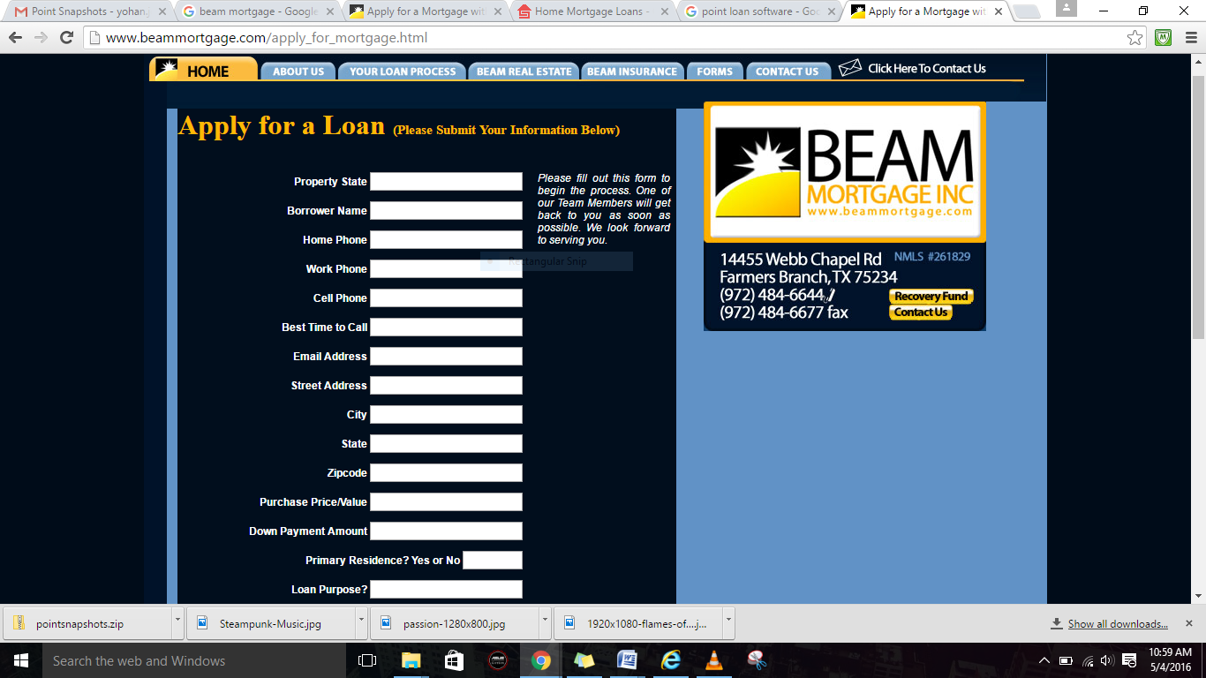

* This page has only minimal values that can be entered to the system by the customer.
* Re-write the format of this application exactly like in the following website link :

<https://www.supremelending.com/secureApp/AppForm.aspx?lo=corporate>

* This is the supreme lending website that enables customer to apply loan online.
* Once the application for is filled, on click of Submit button it should trigger a mail with the application saved/attached in .brw format.
* Note again that the application should be saved in .brw format.
* For more info on .brw format please refer :

<https://www.google.com/webhp?sourceid=chrome-instant&ion=1&espv=2&ie=UTF-8#q=+what+is+.brw+format>

which includes,

<http://fileinfo.com/extension/brw>

<http://dotwhat.net/file/extension/brw/2900>

<http://dllyes.com/brw/>

<http://www.file-extension.org/extensions/brw>

* The software that is being used in BEAM mortgage is called POINT. For more details check their website

<http://www.calyxsoftware.com/>

Screenshots for the Point application that we fill for a client.

1. **Borrower Information**

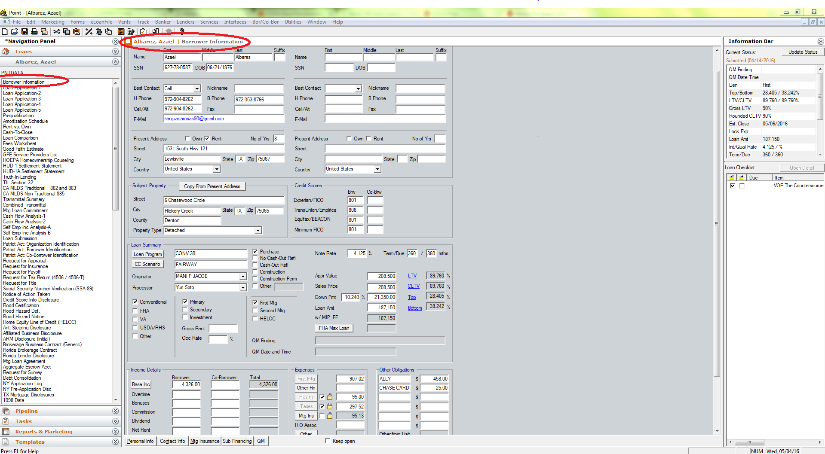

1. **Loan Application-1**

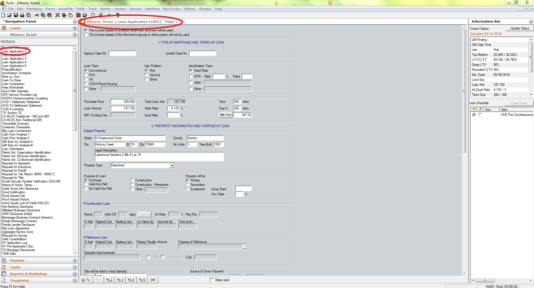

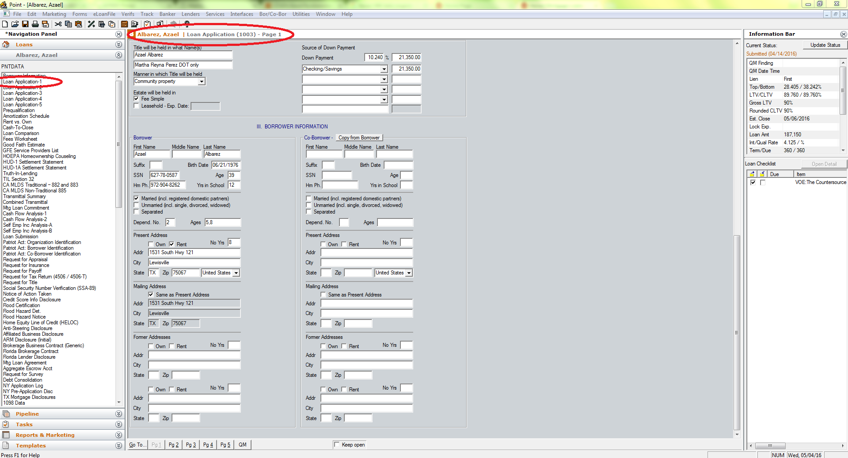

1. **Loan Application-2**

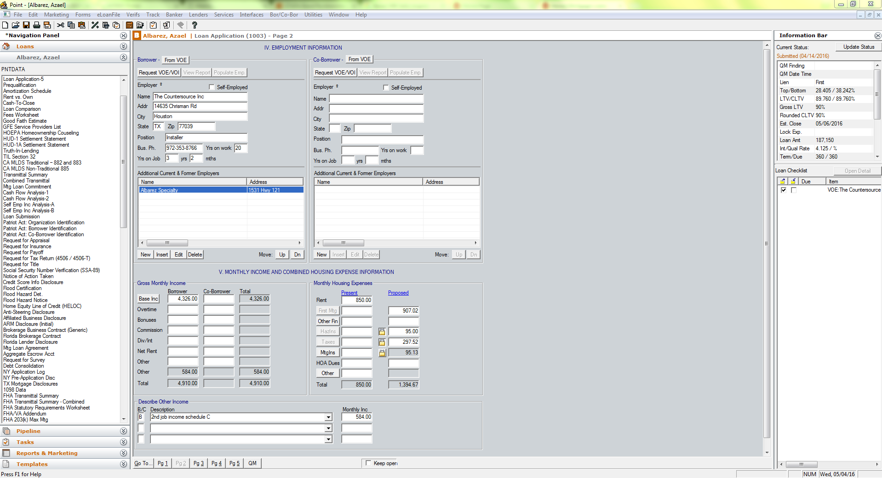

1. **Loan Application-3**

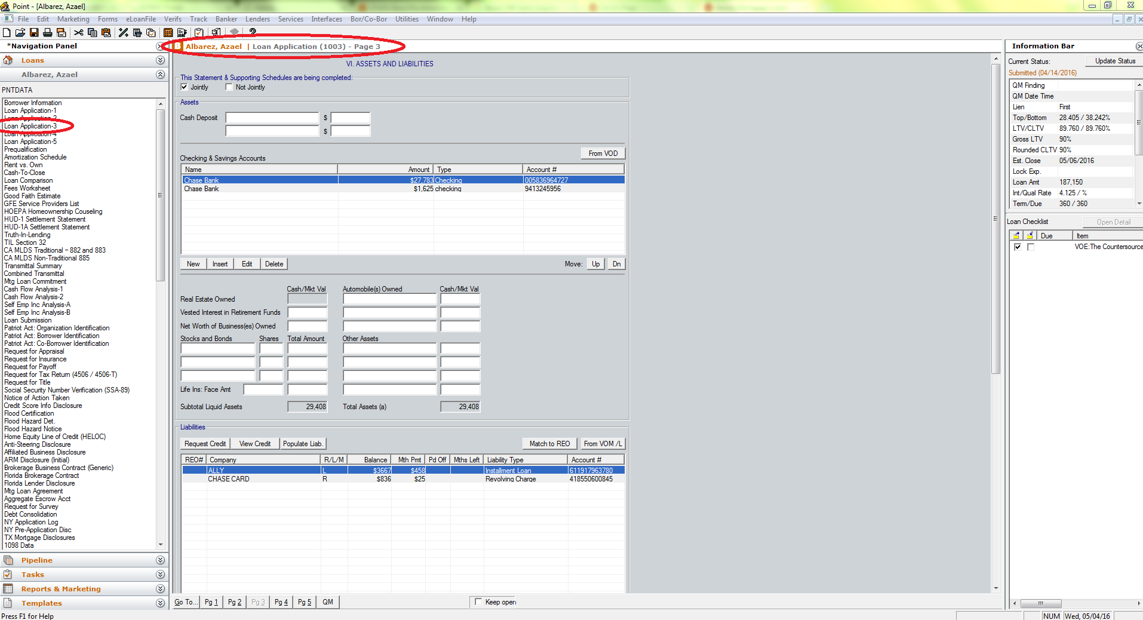

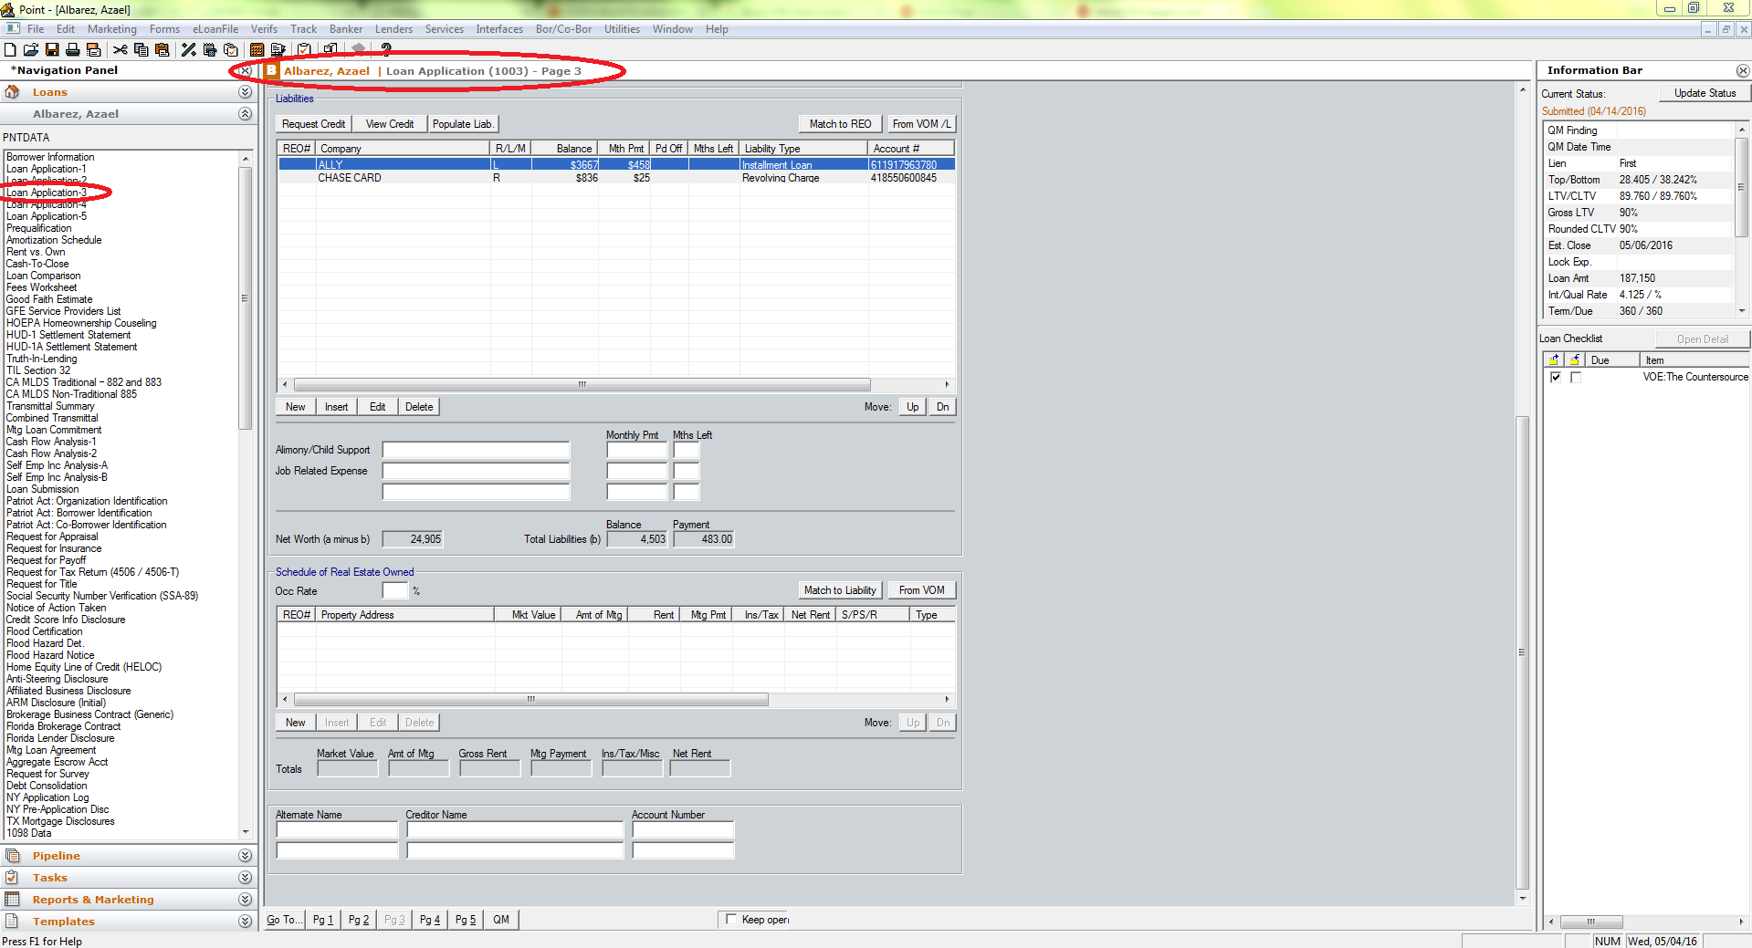

1. **Loan Application-4**

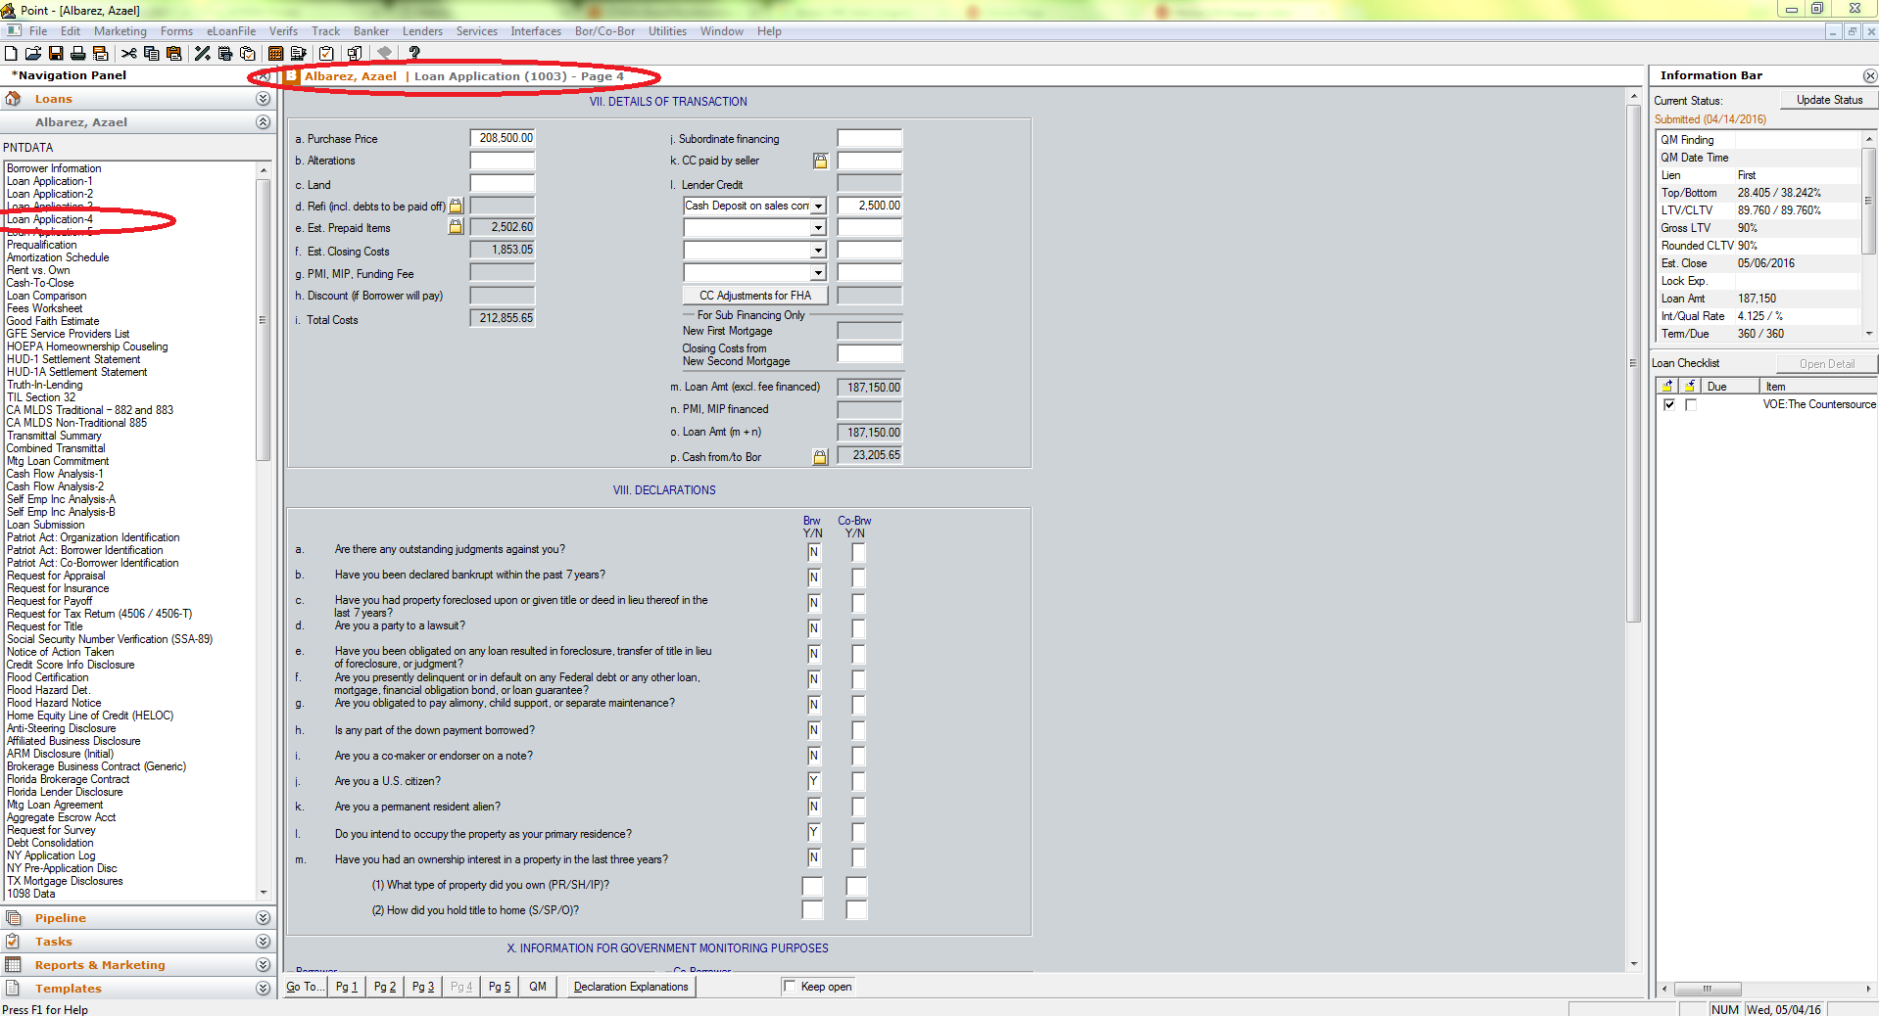

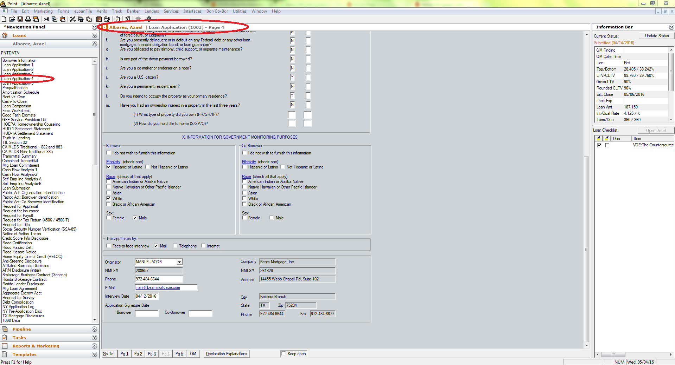

* 1. BEAM Real Estate :

BEAM Real Estate website is providing a link for the agents so as to upload their final closing documents before a cheque is cut for their final settlement.

(Do we have to create a login ID and password for agent login ???)

Here we create a local storage

AWS – Amazon webservices.

Simple linux server that uses basic FTP to put/get files and then an rsync job to the synology to get files from there.

Basic one. A repository with little storage, the synology should go every 30 mins and then check if there are some entries and if yes, pull the entries. Get some storage( Jus like a repository) on your webserver(GoDaddy) and have it drop those files locally. Then the synology will go and run the rsync job from the webserver locally. Make sure that the synology initiates the traffic.

Synology runs an FTP, SFTP job -> something to pull the files securely.

1. **Non Functional Requirements**
   1. Security Requirements

**Identified transaction** – triggers transactions that require that a person be specifically identified. The nature of the transaction may require confirmation of a person's identity (e.g., name, address, birth date, etc.) and/or data linking the person to a transaction (e.g., invoice number, personal health number, etc)

|  |  |
| --- | --- |
| ***Use Case / Business Function Name*** | ***Transaction type triggered***  ***(Level 0 : Anonymous,***  ***Level 1 : Pseudonymous,***  ***Level 2 : Identified,***  ***Level 3 : Verified)*** |
| *Beam Mortgage Loan Application* | *Level 2* |
| *Beam Real estate closing documents Upload* | *Level 0* |
|  |  |

Note:

***Level 0: Anonymous transaction*** *– triggers transactions that do not require or allow a person to be identified, or transactions which require protection of a person's identity. For example, access to online information about government programs or services or protecting a person's identity. Combining the transaction data with other data must not allow identification of a particular individual.*

***Level 1: Pseudonymous transaction*** *– triggers transactions that do not require a person to be identified but do require a means for further contact to deliver a product or service. For example, a note from someperson@internet.ca can not be readily translated into an individual’s name, but it may be sufficient to request information, to provide some services, or on-going follow up.*

***Level 2: Identified transaction*** *– triggers transactions that require that a person be specifically identified. The nature of the transaction may require confirmation of a person's identity (e.g., name, address, birth date, etc.) and/or data linking the person to a transaction (e.g., invoice number, personal health number, etc.).*

***Level 3: Verified transaction*** *– triggers transactions that require: the person to be specifically identified; verification of the integrity of the data exchanged and the exchange itself; and, the creation of sufficient evidence to indicate that the person agreed to be bound by the transaction. For example, a note signed with a digital certificate, audit trails and security logs may provide sufficient evidence that a specific person intended to conduct a transaction.*

* 1. Authorization and Access Controls

This section describes the Authorization and Access Control requirements part of the Business Requirements at a high-level. Authorization is the process of determining if the person/group, once identified through the “Authentication process”, is permitted to have access to certain services. The Authorization and Access Control requirements are best described through a matrix.

1. Beam Mortgage:

*Please specify the Authorization and Access Control requirements between the various Actors/Business Units and the Domain Classes/Business Entities in the table below. Add more rows as necessary.*

|  |  |  |
| --- | --- | --- |
| **Actor / Business Unit Name** | **Conceptual Class / Business Entity Name** | **Type of Access Control needed on the Conceptual Class / Business Entity :**  **C 🡪 Create**  **S 🡪 Submit**  **R 🡪 Read**  **E 🡪 Edit**  **D 🡪 Delete** |
| Beam Mortgage | Customers | C,S,R |
| Beam Mortgage | Admin | C,S,E,D,R |
|  |  |  |

1. Beam Real Estate:

*Please specify the Authorization and Access Control requirements between the various Actors/Business Units and the Domain Classes/Business Entities in the table below. Add more rows as necessary.*

|  |  |  |
| --- | --- | --- |
| **Actor / Business Unit Name** | **Conceptual Class / Business Entity Name** | **Type of Access Control needed on the Conceptual Class / Business Entity :**  **U 🡪 Upload**  **L 🡪 Login**  **R 🡪 Read**  **D 🡪 Delete** |
| Beam Real Estate | Agent | L,U,R |
| Beam Real Estate | Admin/Broker | L,U,R,D |
|  |  |  |

* 1. **Availability Requirements**

*Please specify the availability requirements for each Use Case or Business Function in the table below. Add more rows as necessary. If all use cases / business functions (the system as a whole) have the same uniform availability requirements, then describe this in the space below and delete the table below.*

|  |  |
| --- | --- |
| **Use Case / Business Function Name** | **Availability Requirements**  **- Regular work hours**  **- 24x7**  **- Any other (please describe)** |
| *On- call support to current Customers* | *9:00 AM – 5:00 PM CST time* |
| *Apply for a loan* | *24 x 7* |
| *Upload the Closing Documents* | *24 x 7* |
|  |  |

1. **Interface Requirements**
   1. User Interface Requirements
2. IE
3. Chrome
4. Safari
5. Firefox
6. **Business Glossary**